Student Assessment Submission and Declaration
When submitting evidence for assessment, each student must sign a declaration confirming that the work is their own.
Student name:  Aled |  | Assessor name:  Safaa BaniEssa
Issue date: | Submission date: |  | Submitted on:12/6/2022
Programm:
Higher National Diploma in Computing
Unit 4:Database Design & Development
Assignment number and title:
Assignment 1 : The Beachside Hotel
Your answer here:\
Task 1: Implementing the database system

- Choose an appropriate database management system (DBMS) to design the required database system based on the relational database you designed in the first assignment.
create table customer
(
cusid int primary key,
Fname varchar(25) ,
Lname varchar (25) ,
Phoneunmber varchar (10) ,
address varchar(50) default 'jordan',
gender varchar (10) check(gender='m' or gender='f') ,
birthdate date check (birthdate <'2006')
)

create table room
(
roomnumber int primary key ,
Type Varchar(50) ,
location varchar (10) ,
seaView varchar (10) check (seaview='y' or seaview='no'),
Breakfast Varchar (10) check (Breakfast='y' or Breakfast='no'),
check_in date ,
check_out date,
availability varchar(10) check (availability='available' or availability='unavailable'),
Price Int,
number_of_bed int
)
create table paymentcard
(
Cardid int primary key,
Issuedate date ,
Expiredate date ,
name Varchar(25)
)
create table gym
(
name Varchar(25) primary key,
opening_time Time ,
closeing_time time ,
price int ,
Machinetype Varchar (25) ,
Service Varchar(10)
)
create table spa
(
Name Varchar(25) primary key,
Price char (10) ,
open_time Time,
close_time time
)
create table register
(
Cusid int references customer (cusid),
Namegym varchar(25) references gym(name),
)
INSERT INTO customer(cusid,Fname,Lname,Phoneunmber,address,gender,birthdate)VALUES
(12324,'Ahmed','Khalil','0798546324','zarqa','m','2005'),
(12243,'afnan','jawad','0775432568','','f','2001'),
(84875,'khaled','awwad','0783456783','iraq','m','1999'),
(13435,'nagham','raed','0795436789','dubai','f','2002'),
(12345,'morad','shadi','0795463782','kawit','m','2003'),
(34657,'ghada','samer','0776548467','jordan','f','1997'),
(45646,'jamel','fadi','0795463742','','m','1980'),
(54367,'samera','jaber','0783457896','algera','f','1987');
INSERT INTO room (roomnumber,Type,availability,location,Breakfast,seaView,Price,check_in,check_out,number_of_bed)VALUES
(19,'single','available','seaveiw','y','y',70,'2022-12-12','2022-12-14',1),
(12,'double','available','seaveiw','y','y',100,'2022-12-14','2022-12-16',2),
(25,'double','available','seaveiw','y','y',90,'2022-12-20','2022-12-24',2),
(41,'family','available','noseaveiw','y','no',100,'2022-12-12','2022-12-14',4),
(49,'family','available','noseaveiw','no','no',90,'2022-12-15','2022-12-20',4),
(70,'single','available','seaveiw','y','y',70,'2022-12-17','2022-12-19',1),
(78,'family','available','seaveiw','y','y',100,'2022-12-16','2022-12-18',4);
INSERT INTO paymentcard(name,Cardid,Issuedate,Expiredate)VALUES
('amira jaber',58657,'2022-03-02','2024-03-02'),
('ahmed khalil',12433,'2022-04-01','2024-04-01'),
('afnan jawad',14233,'2022-05-01','2024-05-01'),
('khaled awwad',53543,'2022-06-01','2024-06-01'),
('nagham read',32624,'2022-07-01','2024-07-01'),
('morad shadi',42667,'2022-09-01','2024-09-01'),
('ghada samer',74356,'2022-02-01','2024-02-01'),
('jamel fadi',42654,'2022-01-01','2024-01-01');
INSERT INTO gym(name,opening_time,closeing_time,price,Machinetype,service)VALUES
('golden gym','12:00:00','12:00:00',20,'french machine','yes');
INSERT INTO spa (name,open_time,close_time,price)VALUES
('golden spa','12:00:00','12:00:00',15);
INSERT INTO register(Cusid ,Namegym)VALUES
(12324,'golden gym'),
(12243,'golden gym'),
(84875,'golden gym'),
(13435,'golden gym'),
(12345,'golden gym'),
(34657,'golden gym'),
(45646,'golden gym'),
(54367,'golden gym');
select * from Customer;
select * from room;
select * from paymentcard;
select * from gym;
select * from spa;
select * from register;

- Make the system useful and easy to use for Beachside hotel customers by doing the following:

- Apply the requested queries to perform the needed operations and retrieve useful data. Also, at the manager’s request, suggest additional queries to determine the possibility of extracting valuable information and facilitating the management process.
Registration and deletion of customers
update customer
set CustomerID
where cusid

delete from customer
where cusid
Adding, deleting and updating rooms, payment card and services
update room
set availability = 'available'
where roomnumber = 70

delete from room
where roomnumber = 70

update paymentcard
set Cardid = 74356
where name = 'khaled awwad'

delete from paymentcard
where Cardid = 12433

update spa
set open_time = '01:00:00'
where open_time = '12:00:00'

delete from spa
where name = 'golden spa'
Updating the reservation status (Availability) for the rooms
update room
set availability = 'available'
where availability = 'unavailable'
All unreserved rooms ordered by number of beds, in descending order

select number_of_bed ,('unavailable')availability
from room
group by number_of_bed
Order by number_of_bed DESC

All double and family rooms with a price below 100$ per night, in ascending order of price.

select Price,count('double''family') type
from room
group by Price having count('double''family')< 100
order by Price ASC

Total revenue per night from all double rooms

select price,sum(price)over( order by ('double'))
from room
group by Type

- Create simple interfaces to insert, update and delete data in the database and Implement the validation methods mentioned in the scenario.

- Based on the user and system requirements, measure the implemented database solution by listing each requirement along with where it was met and how it was achieved. In addition, recommend improvements based on the assessment

Room_service | room_service varchar(12) check  (room_service = 'yes' or room_service 'no')
Food_service | food_service varchar(12) check  (food_service = 'yes' or food_service 'no')
Attending_parties | Attending_parties varchar(12) check  (Attending_parties = 'yes' or Attending_parties= 'no')
Do not include any room without specifying the number of beds | Not null
If the customer did not fill in the address, fill it with "Jordan" by default. | By defualt
All customers must be over 18 years old | Check
Fill in the room availability with 'Available' or 'Unavailable' option only. Also, the sea view option and breakfast option with “yes” or “no” options only. | check
Adding, deleting and updating rooms, payment card and services | Insert , update , delete

All unreserved rooms ordered by number of beds, in descending order | Count()
All double and family rooms with a price below 100$ per night, in ascending order of price. | Count()
Total revenue per night from all double rooms | Sum()
Total number of customers who booked a single room with sea view option | Sum()

Shaded in black are my suggestions for improvement

Task 2: Testing the database system

- Check the system against user and system requirements and provide relevant test cases for the database you have implemented. Also, analyse how the selected test data can be used to improve the effectiveness of testing.
test availablitiy

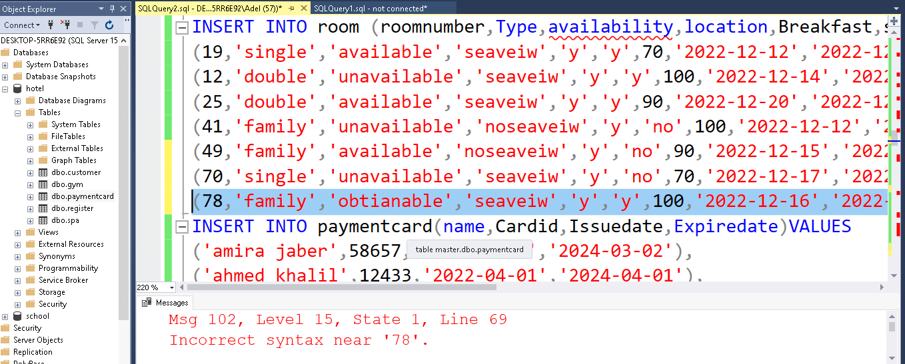
test age 2006
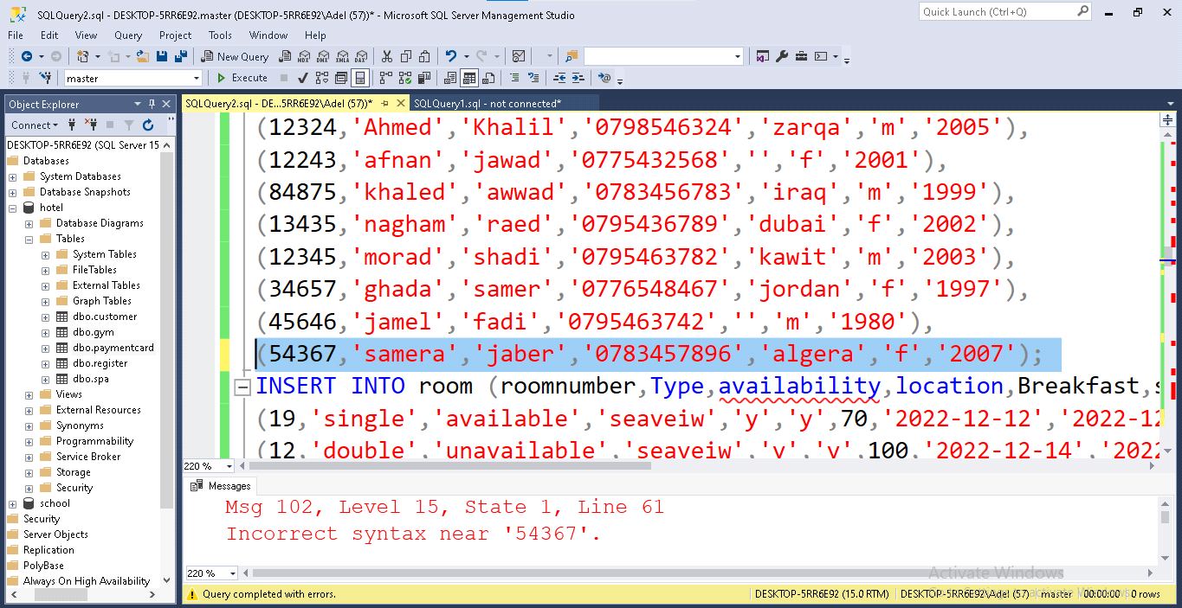
test y or no breakfasr
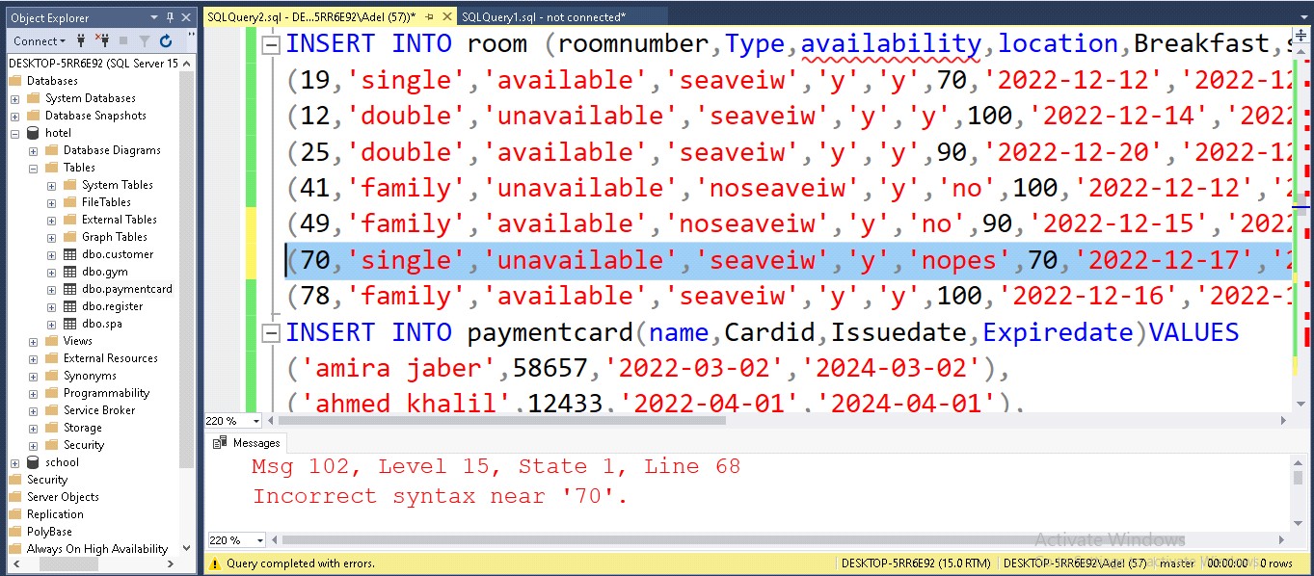
test y or no seaview
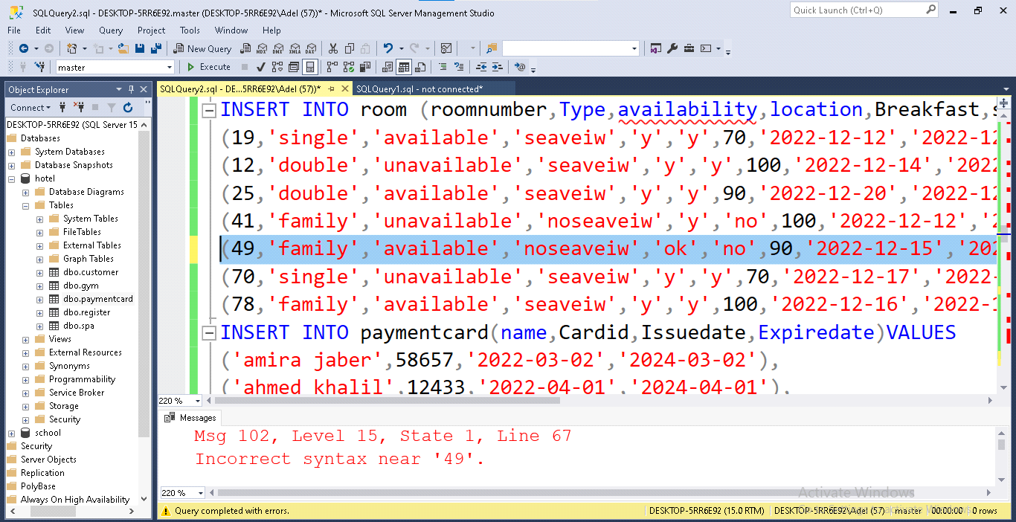
test number_of_bed
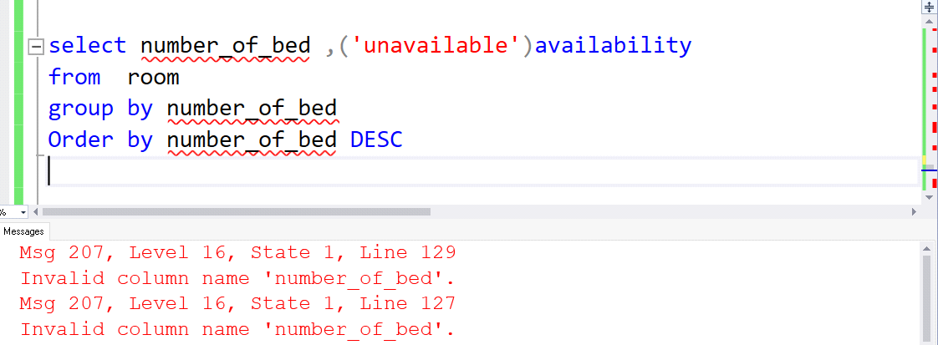
test update
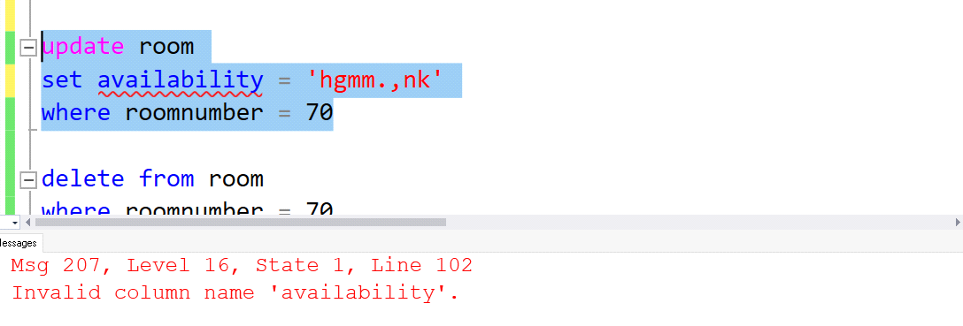
test delete
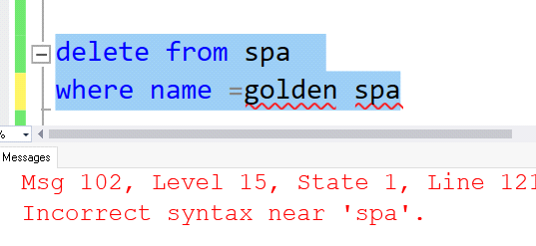
test price of double
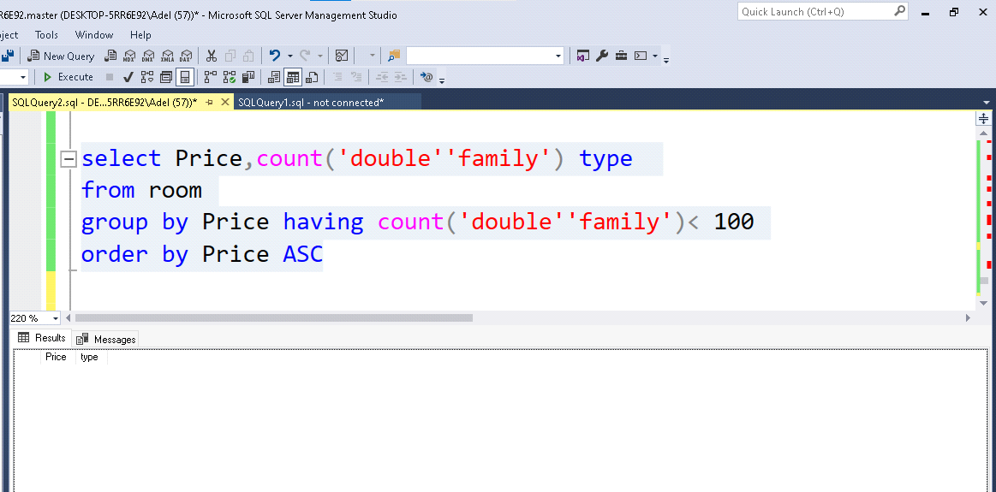

- Assess the implemented database by discussing improvements that may be required and can be applied to scale the system.

We can provide swimming pools for visitors, and they may be free for customers who book for long days, and we can open a nightclub that is part of the hotel services, and it has light fees for customers inside the hotel and inside fees for customers from outside the hotel, as well as adding a restaurant inside the hotel that serves customers
We will add this to the Database through tables and requisitions that are arranged.

You are also required to document your work and generate an organized technical documentation that includes system requirements and functionalities, activity diagram, user manual, interfaces and so on….

Recommended Resources
Please note that the resources listed are examples for you to use as a starting point in your research – the list is not definitive.

Elmasri. Fundementals of Database System. 7th Ed.

Learning Outcomes and Assessment Criteria

Pass | Merit |  | Distinction
LO2 Develop a fully functional relational database system, based on an existing system design
P2 Develop the database system with evidence of user interface, output and data validations, and querying across multiple tables.  P3 Implement a query language into the relational database system. | M2 Implement a fully functional database system which includes system security and database maintenance. M3 Assess whether meaningful data has been extracted through the use of query tools to produce appropriate management information. |  | LO2 & 3 D2 Evaluate the effectiveness of the database solution in relation to user and system requirements, and suggest improvements.
LO3 Test the system against user and system requirements
P4 Test the system against user and system requirements. | M4 Assess the effectiveness of the testing, including an explanation of the choice of test data used.
LO4 Produce technical and user documentation
P5 Produce technical and user documentation. |  | M5 Produce technical and user documentation for a fully functional system, including diagrams showing movement of data through the system, and flowcharts describing how the system works | D3 Evaluate the database in terms of improvements needed to ensure the continued effectiveness of the system.

